Trout Food Drive!

Dear Parents and Guardians,
Our School will be collecting dry and canned goods to donate to our community. The food drive will be held November 30th- December 9th. We will have a friendly competition between all three grade levels. The grade level that brings the most food donations by December 9th will have milk and cookies in the cafeteria while he watching a short holiday movie on Friday, December 11th !
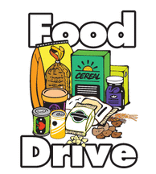
All food donations need to be taken to your child’s classroom. It will be collected and counted daily. We are asking for dry and canned goods. Here are a few suggestions.

- Canned Vegetables
- Canned Fruit
- Canned Soup
- Canned Tuna or Chicken
- Dry Beans or Rice
- Fruit Juices
- Nuts
- Peanut Butter
- Cereal
- Oatmeal
- Crackers

Every student that brings a donation will receive a ticket to wear their favorite pajamas to school on Friday December 18th!
Thank you so much for all of your help!
---------------------------------------------------------------
Holiday Pictures
On December 11th students will have the opportunity to take a holiday picture! These pictures will be printed and sent home! They can make a great addition to your holiday cheer! If you would like your child to take a holiday picture please complete the bottom portion of this form and send it back to school with your child.
Cost: 2 Pictures for $5 (Cash Only)
Student Name:__________________ Teacher:__________________
Not Paid
Paid

