Trout Food Drive

Dear Parents/Guardians,
Our school will be collecting dry and canned goods to donate to our community. The food drive will be held November 26th- December 7th.
We will have a friendly competition between all three grade levels. The grade level that brings the most food donations will have milk and cookies in the cafeteria on December 14th while Santa reads them a story.
All food donations need to be taken to your child’s classroom. It will be collected and counted daily.
We are asking for dry and canned goods. Here are some suggestions:
Canned vegetables
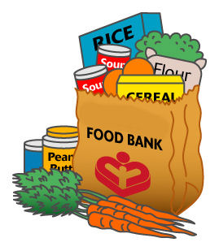
Canned fruit
Canned soup
Canned tuna or chicken
Dry beans or rice
Fruit juices
Nuts
Peanut butter
Cereal
Oatmeal
Crackers
Thank you for your help!

