Assignment: Solving Square Root Inequalities
Name ________________________________
Date ___________________ Period ________

Use transformations to solve each inequality.
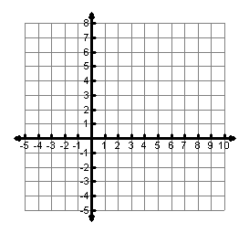
1. $\sqrt{x+2}≥2$ 2. $\sqrt{x}+5≤7$ 3. $\sqrt{x+1}+3>5$
4. $2\sqrt{x-3}≤4$ 5. $3\sqrt{x+4}-3>3$ 6. $-\sqrt{x}+5>3$
Review: Solve. Show Work!

7. $\sqrt{x+3}=2$ 8. $\sqrt{3x-6}=3$ 9. $\sqrt{2x+1}=3$

10. $-2\sqrt{x}+5=1$ 11. $\sqrt{4x-8}=6$ 12. $3\sqrt{x+5}-6=0$

