Assignment: Review Systems
Name ________________________________
Date ___________________ Period ________
NO CALCULATOR
Solve each system by graphing.

1. $y=4x-5$ 2. $x+y=-8$
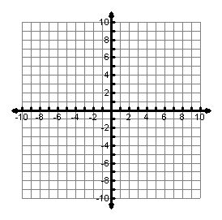
$y=7-2x$ $3x+3y=9$

Graph each inequality.

3. $x≤5$ 4. $y≥2x$
$y>2x-4$ $y≤x+1$
$-x-3y≤15$

Is (0, -6) a solution? ____ Is (-2, -3) a solution? ____

Write the system of equations shown below and state the solution.
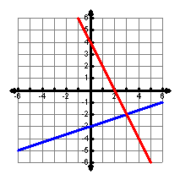
5.

CALCULATOR
Solve each system by elimination or substitution.

6. $x=2y-1$ 7. $x-y=0$ 8. $3x-5y=8$
$2x+3y=-16$ $4x+10y=42$ $6x-10y=24$

Solve each system by any method. (If you use a matrix, be sure to write the matrix equation.)

9. $2x-4y=16$ 10. $6x=3y-6$ 11. $3x+9y=-30$
$-x-2y=-16$ $7y=5x+41$ $x=2+3y$

12. $3x=16+4y$ 13. $x+3y=19$ 14. $x+y-3z=-13$
$6y=14-5x$ $x=y-1$ $2x-y-2z=-1$
$3x-2y+z=16$

Define the variables, write a system and solve.
15. The perimeter of a rectangle is 44 m. The length is 4 m more than the twice the width. Find the dimensions.

16. Tickets to a basketball game cost $1.50 for students and $3.25 for adults. The school made $752.25 and sold 358 tickets. How many student and how many adult tickets were sold?

