Assignment: Review Equations and Inequalities
Name _____________________________
Date_____________________Pd._______
Calculator
Solve.

1. $8\left|x\right|=32$ 2. $-2\left|x+3\right|+1=6$ 3. $11\left|x-9\right|=121$

4. $5\left|2x-3\right|-6=29$

Solve algebraically and graph using a number line.

5. $\left|2x\right|≤-5$ 6. $-7\left|x-10\right|>-49$ 7. $4\left|x-1\right|+8≥12$

8. $\left|x+15\right|≤37$ 9. $-2\left|x+3\right|>6$

Graph. No Calculator

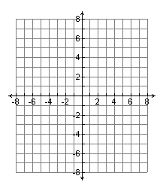
10. $f\left(x\right)=3\left|x\right|-6$ 11. $f\left(x\right)=-\left|x+1\right|+4$
Vertex
Domain
Range
Max/Min
x-intercept

y-intercept
Vertex
Domain
Range
Max/Min
x-intercept

y-intercept

What are the solutions of the What are the solutions of the
equation $3=3\left|x\right|-6$? equation $2≥-\left|x+1\right|+4$?

Write the equation of the functions graphed below.
14. 15.
