Assignment: Solving Absolute Value Inequalities Graphically
Name ________________________________
Date ___________________ Period ________

Solve by graphing.

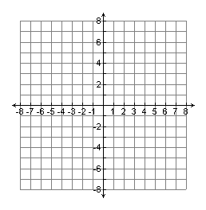
1. $\left|x\right|-4≥-2$ 2. $2\left|x\right|≤6$ 3. $\left|x+1\right|-4<2$
Solution:____________ Solution:____________ Solution:____________

4. $\left|x-3\right|-5>-1$ 5. $-2\left|x\right|-3≥-7$ 6. $-\left|x-2\right|+5≤2$
Solution:____________ Solution:____________ Solution:____________

Use the table to solve.

7. $\left|x\right|+3≥4$ 8. $\left|3x\right|+2≤8$
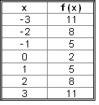
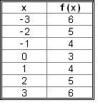

Solution:____________ Solution:____________

Review:
Solve.

9. $3\left|x-1\right|+4=7$$\left|x+5\right|+3≤10$ 10. $3\left|x-1\right|+4≥7$$\left|x+5\right|+3=10$

11. $\left|2x-5\right|=5$ 12. $-4\left|x\right|+3=-5$

