Assignment: Solving Systems Using 3 Methods

Name ________________________________

Date ___________________ Period ________

**Solve by graphing.**

1. 2.

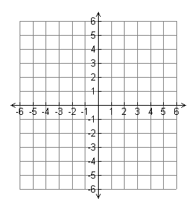

3. 4.



**Solve by substitution or elimination. Show Work!**

5. 6.

7. 8.

9. 10.

11. 12.