**Assignment: Systems of Linear Inequalities**

Name ________________________________

Date ___________________ Period ________

**Graph the system of linear inequalities.**

1. 2. 3.

Is (-3, -4) a solution? ____ Is (5, 0) a solution? ____ Is (0, -4) a solution? ____

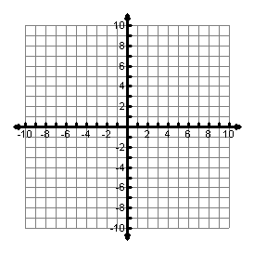

4. 5. 6.

Is (-3, 3) a solution? ____ Is (2, 4) a solution? ____ Is (-4, 2) a solution? ____



7. 8.

Is (-1,5) a solution? ____ Is (2, -4) a solution? ____



9. Which of the following systems of inequalities describes the graph shown?

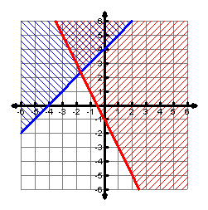

A.  C. 

B.  D. 

10. A class fundraiser is charging $7 per car wash *w* and $4 per cake *c* sold. The cakes cost $2 to make and the supplies for the car wash cost $1 per car. They will wash less than 50 cars and bake no more than 30 cakes. They want to make a profit of at least $320 to give to a local charity. What system represents this situation?

F. $w<50$ G. $w<50$ H. $w<50$ J. $w<50$

$c≤30$ $c≤30$ $c≤30$ $c≤30$

$w+ c≤320$ $6w+ 2c≥320$ $5w+3c≥320$ $7w+ 4c≥320$