Assignment: Systems by Graphing
Name ________________________________
Date ___________________ Period ________
Solve each system by graphing.

- $y+x=5$ 2. $3y+6x=3$ 3. $x-y=0$
$y-3x=1$ $x-y=-7$ $8x+4y=-24$
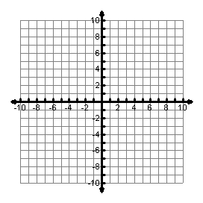
Solution: __________
Solution: __________
Solution: __________

4. $x-y=-1$ 5. $2+y=x$ 6. $4y-2x=4$
$4x-2y=2$ $x+y=4$ $10x-5y=10$

Solution: __________
Solution: __________
Solution: __________
7. $2x-3y=-15$ 8. $2x+2y=-10$ 9. $8y-24x=64$ $3y-2x=15$ $4x+4y=16$ $9y+45x=72$

Solution: __________
Solution: __________
Solution: __________

Determine if the given ordered pair is a solution to the system of equations. Show Work!
10. $(-2,2)$ 11. $(-3,-5)$ 12. $(6,1)$
$x+y=0$ $2y-6x=8$ $y=8x+2$
$7y-14x=42$ $4y=8x+4$ $x-3y=3$

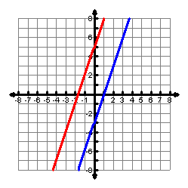
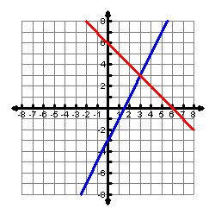
Write the system of equations shown on the graph. State the solution to the system.
13. 14.

System: ________________ Solution: ______

System: ________________ Solution: ______

