_________________________________ Unit 9 Day 4 Assignment

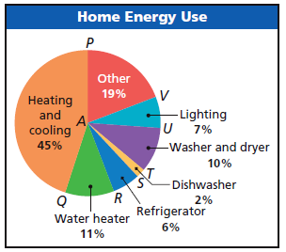

**Guided Practice**

The circle graph shows how a typical household spends

money on energy. Find each of the following.

1)mPAQ

2) m

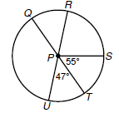

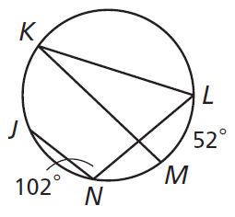**3-6 Find each measure.**

3) m 5) m

4) m 6) m

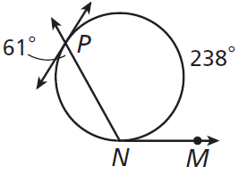**7-11 Find Each measure.**

7) m 8)m

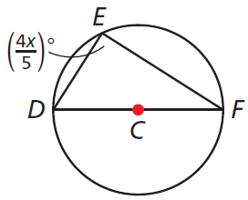

9) x =

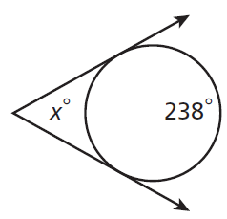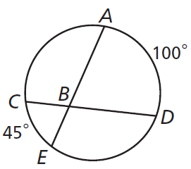

10) m 11) x =

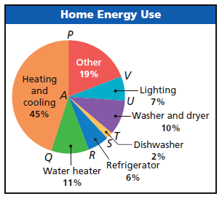**Practice and Problem Solving**

Find each of the following.

12) mSAQ

13) m

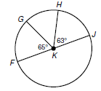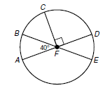**14-24 Find each measure.**

14) m 16) mCE

15) m 17) mBD

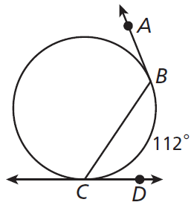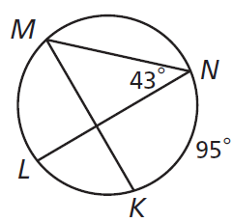

18) m 20) m

19) m 21) m

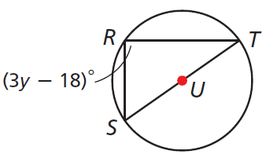

22) y = _______

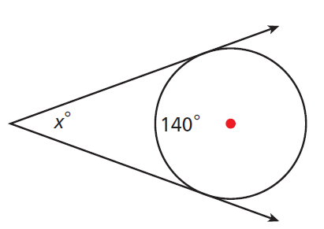

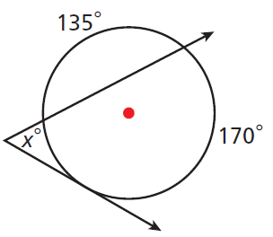

23) x = _______ 24) x = _______