_____________________________ Unit 9 Day 2 Assignment

**Guided Practice**

Tell whether each figure has line symmetry. If so, draw all lines of symmetry.

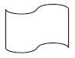 1. 2. 3.

Tell whether each figure has rotational symmetry. If so, give the angle of rotational symmetry and the order of the symmetry.

4. 5. 6.

Identify the symmetry in each wallpaper border pattern.

 7. 8.

**Practice and Problem Solving**

Tell whether each figure has line symmetry. If so, draw all lines of symmetry.

9. 10.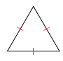 11.

Tell whether each figure has rotational symmetry. If so, give the angle of rotational symmetry and the order of the symmetry.

12. 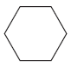 13. 14.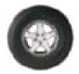

Identify the symmetry in each wallpaper border. (*translation symmetry* and *glide reflection* *symmetry*)

 15. 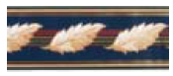 16. 17.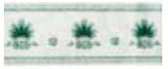

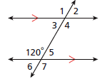Review

**Use the 120 to find each angle measure.**

**Justify each answer with a postulate or theorem.**

19. m1 18. m4

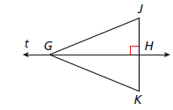20. Given that GJ = 70.2, JH = 26.5, and GK = 70.2, find JK.