_______________________________ Assignment Unit 8 Day 5

**Guided Practice**

1) A point is chosen randomly on. Find the probability of picking a point not on .

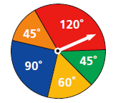

red

Green

Orange

Blue

Yellow

Use the spinner to find the probability of the pointer:

2) landing on orange or blue.

3) not landing on red

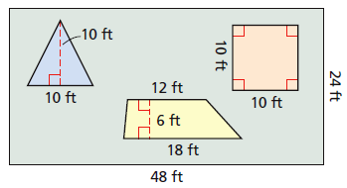4) Find the probability that a point chosen randomly inside the rectangle is in the triangle.

Round to the nearest hundredth.

**Practice and Problem Solving**

5) A point is chosen randomly of . Find the probability of picking a point on .

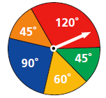

red

green

orange

blue

yellow

Use the spinner to find the probability of each event.

6) the pointer landing on green.

7) the pointer landing on yellow or blue.

8) Find the probability that a point chosen randomly inside the rectangle is in the trapezoid.

Round to the nearest hundredth.

**Review**

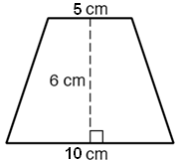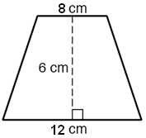9) What is the area of the trapezoid? 10) What is the area of the trapezoid?

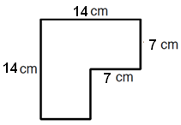

11) Find the area of the figure. Assume all angles are right angles.

12) A parallelogram has a 10-inch base. If the parallelogram

has an area of 72 square inches, what is the height of the

parallelogram?

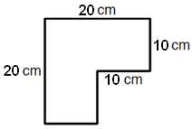13) Find the area of the figure. Assume all angles are right angles.

14) A parallelogram has an 5-inch base. If the parallelogram

has an area of 95 square inches, what is the height of the

parallelogram?

15) The area of a triangle is 30 cm. The length of the base is 4 cm. What is the height?