Assignment: Multiply and Divide Rational Expressions
Name ________________________________
Date ___________________ Period ________
Simplify.
1. $\frac{4xy^{2}}{10y^{3}}∙\frac{3y}{x^{3}y^{3}}$ 7. $\frac{3x^{2}y}{y^{3}}÷\frac{2x^{2}y^{2}}{8y^{2}}$

2. $\frac{x^{2}y}{4xy}∙\frac{3y^{5}}{x^{4}}$ 8. $\frac{{10x}^{4}y}{5xy^{2}}÷2x^{2}y$

3. $\frac{x+4}{2x-6}∙\frac{4x-12}{5x+20}$ 9. $\frac{x+3}{x^{2}-2x+1}÷\frac{x+3}{x-1}$

4. $\frac{x^{2}-2x-8}{x^{2}-9}∙\frac{x^{2}+10x+21}{x^{2}-16}$ 10. $\frac{x^{2}-25}{2x^{2}+5x-12}÷\frac{x^{2}-3x-10}{x^{2}+9x+20}$

5. $\frac{6x^{2}+18x}{x^{2}+9x+8}∙\frac{x^{2}-1}{2x+6}$ 11. $\frac{1}{{25x}^{2}-49}÷\frac{x}{10x-14}$

6. $\frac{4x^{2}-3x}{4x^{2}-1}∙\frac{2x+1}{x}$ 12. $\frac{x-1}{x^{2}+5x+6}∙\frac{x^{2}+x-2}{3}÷\frac{x-1}{3x}$

13. Which of the following is a horizontal asymptote of $f\left(x\right)=\frac{1}{x^{2}-9}$?

A x = -3 B y = 3 C x = 1 D y = 0

14. Which of the following equations could represent the given graph?

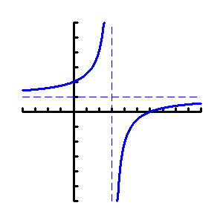

F. $f\left(x\right)=\frac{x+3}{x-1}$ H. $f\left(x\right)=\frac{x-6}{x-3}$

G. $f\left(x\right)=\frac{x-2}{x-3}$ J. $f\left(x\right)=\frac{x+6}{x-3}$

