____________________________ Assignment Unit 7 Day 4

**Guided Practice**

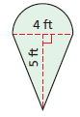Find the shaded area. Round to the nearest tenth, if necessary.

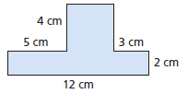1) 2)

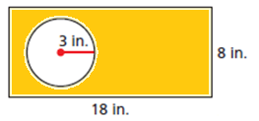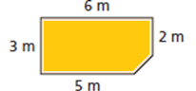

3) 4)

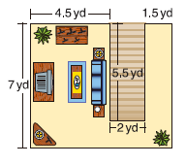

5) Barbara is getting carpet installed in her living room

and hallway. The cost of installation is $6 per square

yard. What is the total cost of installing the carpet?

**Practice and Problem Solving**

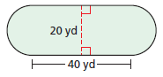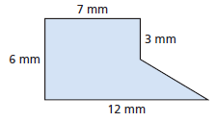Find the shaded area. Round to the nearest tenth, it necessary.

6) 7)

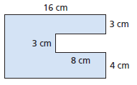

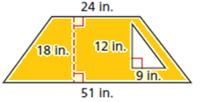8) 9)

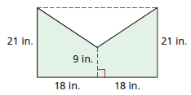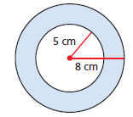10) 11)

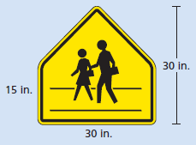

Use the school crossing sign shown to answer problems 12-13.

12) Find the area of the sign.

13) Because of the shape of the sign, a manufacturer can only make

6 signs from a rectangular sheet of metal 45 in. by 105 in. How much

metal will be left after the six signs are made?

Review

14) The area of a triangle is 12.75 m2. If the base of the triangle is 3 m, what is the height of the triangle?

15) ***d*** of a kite in which A = 4x cm, ***d*** = 2 cm