__________________________ Assignment Unit 7 Day 2

**Guided Practice**

45 mm

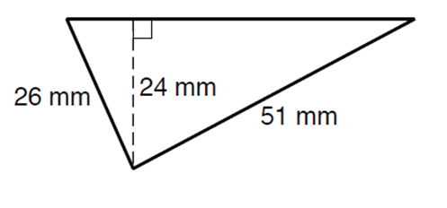

1. Find the area of the triangle.

A =

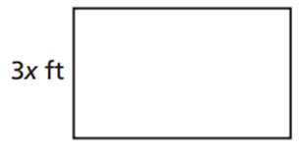

2. Find the perimeter of the rectangle in which A = 15x ft.

P =

**Practice and Problem Solving**

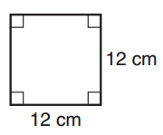**Find the Area of each of the following shapes.**

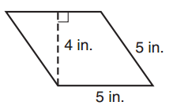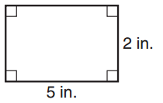

3. 4. 5.

A = A = A =

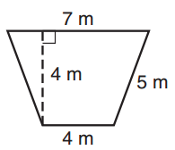

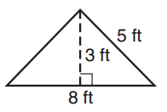

6. 7. 8.

5 m

13 m

12 m

A = A = A =

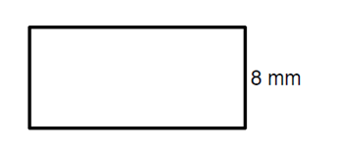9. Find the base and perimeter.

b = P=



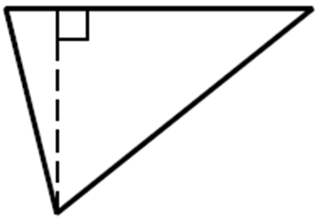

10. Find the height of the triangle in which A = 192 cm.

h =

11. The area of a square is 225 square inches. What is the perimeter of the square?

P =

12. Find *d* of a kite in which *d* = 16 cm and A = 48 cm *d=*

13. A trapezoid has an area of 132 m2. If the bases are 20m and 24m, find the height.

h =

14. The area of a parallelogram is 57 square units. If the height is 6 units what is the base?

b =

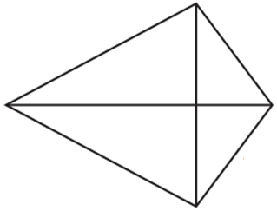

*d*= 18 ft

*d=* 13 ft

15. What is the area of the kite?

A=

16. A rectangle has an area of 192 in2 and a perimeter of 56 in. What are the dimensions?

A) 10 x 15 B) 8 x 24 C) 8 x 12 D) 12 x 16