__________________________ Assignment Unit 7 Day 1

Guided Practice
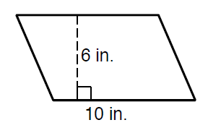
Find the Perimeter and Area for each of the following shapes.
17 in

32 in

8 in

12 in

10 in

7.5 in.

1. 2.

P =
A =
P =
A =

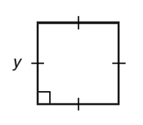
7 + t
t
3. 4.

P =
A =
P =
A =

5. A puzzle contains a triangular piece with a base of 3 in and a height of 4 in. A manufacturer wants to make 80 puzzles. Find the amount of wood used if each puzzle contains 20 triangular pieces.

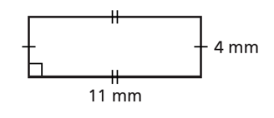
Practice and Problem Solving
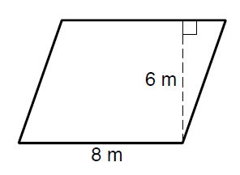
6.5 m
6. 7.

P =
A =
P =
A =

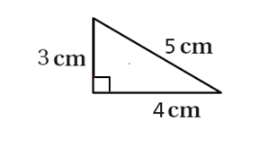
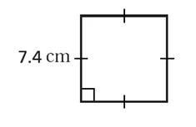
8. 9.

P =
A =
P =
A =

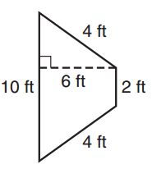

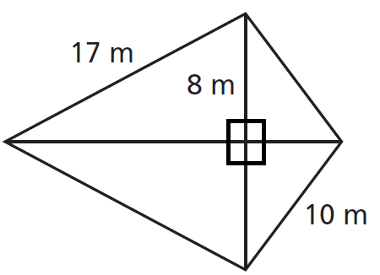
10. 11.
6 m
15 m

8 m

P =
A =
P =
A =

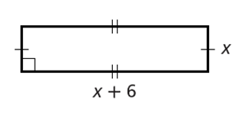
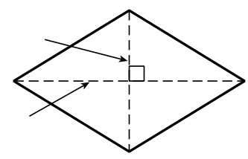
d1 = 12 cm
d2 = 16 cm
20 cm
20 cm
12. 13.

P =
A =
P =
A =

14. A quilt pattern includes 32 small triangles. Each has a base of 3 in. and a height of 1.5 in. Find the amount of fabric used to make the 32 triangles.

4x in
5x + 3 in
7x - 2 in
15. Which expression represents the Perimeter of the triangle?
A. 9x + 3 in B. 16x + 1 in

C. 11x + 1 in D. 16x + 5 in

