Assignment: Review Transformations
Name ________________________________
Date ___________________ Period ________
Given: $f(x)$ NO CALCULATOR
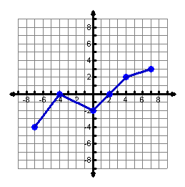

Domain: f(-7) =

Range: f(4) =

Zeros: f(0) =

For what values of x is f(x) = 2?

Use the graph of f(x) to graph:
1. $y=f\left(x\right)+3$ 2. $y=f\left(x-1\right)-2$
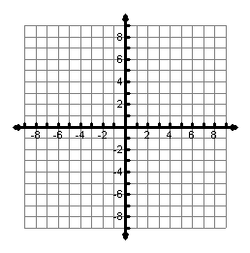
Domain:

Range:

For what values of x is y = 0?
Domain:

Range:

How many zeros does y have?

3. $y=-f(x)$ 4. $y=2f(x+1)$
Domain:

Range:

For what values of x is y = 4?
Domain:

Range:

What are the zeros of y?

Graph each function.

5. $f\left(x\right)=\sqrt{x+3}-1$ 6. $g\left(x\right)=2\left|x\right|-4$ 7. $h\left(x\right)={-\left(x-2\right)}^{2}+4$
Domain:

Range:

For what values of x
is f(x) > -5?
Domain:

Range:

For what values of x
is f(x) = 4?
Domain:

Range:

How many zeros
does f(x) have?

8. $m\left(x\right)=\frac{1}{2}\left|x+1\right|-3$ 9. $g\left(x\right)=3x^{2}-5$ 10. $h\left(x\right)=-2\sqrt{x-2}+3$
Domain:

Range:

How many zeros does
f(x) have?
Domain:

Range:

For what values of x
is f(x) = -2?
Domain:

Range:

For what values of x
is f(x) < -2?

Write the function shown on each graph below.

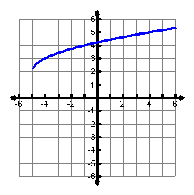
11. _______________ 12. _______________ 13. _______________
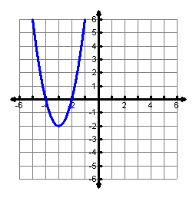
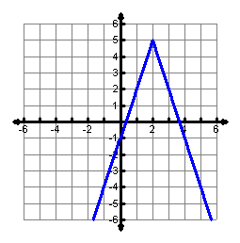
P

Put each equation into vertex form, name the vertex and graph.
14. $f\left(x\right)=x^{2}-4x+5$ 15. $f\left(x\right)=x^{2}+6x+10$ 16. $f\left(x\right)=x^{2}+8x+13$

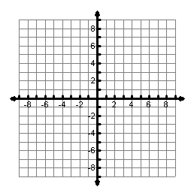
Vertex:

Domain:

Range:

For what values of x
is f(x) = 5?
Vertex:

Domain:

Range:

How many zeros does
f(x) have?
Vertex:

Domain:

Range:

For what values of x
is f(x) < 6?

17. Graph the inverse of f(x).

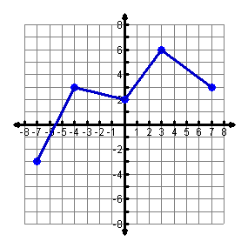

Graph each function and the inverse.
18. $f\left(x\right)={\left(x-3\right)}^{2}+2$ 19. $g\left(x\right)=\sqrt{x+4}-3$

Graph the function, find the inverse algebraically and graph the inverse.

20. $h\left(x\right)=4x-8$

