Name ________________________________

Date ___________________ Period ________

**Assignment: Solving Exponential Equations with Different Bases**

**Solve. Round to the nearest hundredth.**

1. 2. 3.

4. 5. 6.

7. 8. 9.

10. 11. 12.

13. 14. 15.

16. The expression  is equal to

F  G 

H *N* J 

17. Which equation is represented by the graph in the accompanying diagram?

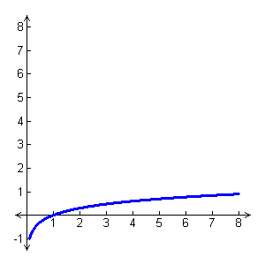



18. Convert  to exponential form: ______________________