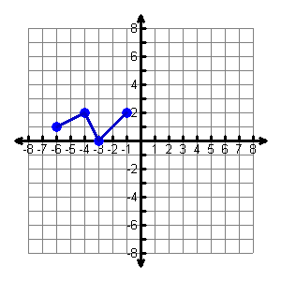
Assignment: Transforming Functions
Name ________________________________
Date ___________________ Period ________
Unit 7
Day 5
Given $g(x)$

Domain:

Range:

Zeros:

For what value of x, does $g\left(x\right)=-1$g(x) = 2?

For what values of x, is $g\left(x\right)=0$?

Use the graph of $g(x)$ to graph:

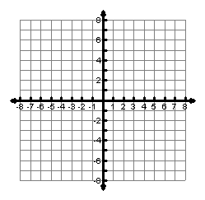
1. $y=g\left(x-3\right)+2$ 2. $y=-g\left(x+2\right)$
Domain:

Range:

For what values of x is y = -2?
Domain:

Range:

For what values of x is y = 2?

3. $y=2g(x)$ 4. $y=\frac{1}{2}g\left(x\right)$

Domain:

Range:

For what values of x is y = 0?
?
Domain:

Range:

What are the zeros of y?

5. $y=-h\left(x\right)+2$
Given $h(x)$
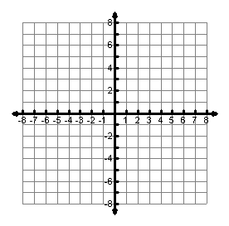
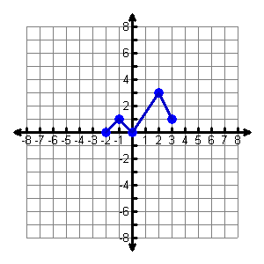
Domain:

Range:

For what values of x is y = 2?
Domain:

Range:

For what values of x is y = 0?

6. $y=h\left(x+2\right)-3$ 7. $y=\frac{1}{2}h\left(x+3\right)$
Domain:

Range:

What are the zeros of y?
Domain:

Range:

For what values of x is y = -2?

8. $y=2h\left(x-2\right)-3$ 9. ____________________
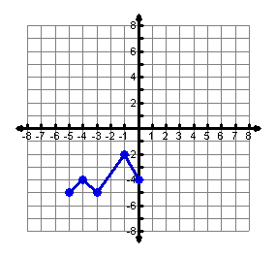
Domain:

Range:

For what values of x is y = -3?

