Assignment: Graphing Cube Root Functions
Name ________________________________
Date ___________________ Period ________
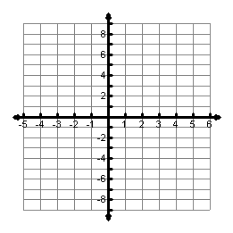
1. $f\left(x\right)=\sqrt[3]{x+2}$ 2. $f\left(x\right)=\sqrt[3]{x-3}+1$
Inflection Point:

Domain:

Range:

Zeros:

Inflection Point:

Domain:

Range:

Zeros:

3. $f\left(x\right)=2\sqrt[3]{-x}$ 4. $f\left(x\right)=-\sqrt[3]{x}+2$

Inflection Point:

Domain:

Range:

Zeros:

Inflection Point:

Domain:

Range:

Zeros:

5. $f\left(x\right)=-2\sqrt[3]{x-2}-1$ 6. $f\left(x\right)=-\frac{1}{2}\sqrt[3]{x+2}-2$

Inflection Point:

Domain:

Range:

Zeros:

Vertex:
Axis of Sym:
Domain:
Range:
Zeros:
Max/Min
Inflection Point:

Domain:

Range:

Zeros:

7. $f\left(x\right)=2\sqrt[3]{x+3}-7$ 8. $f\left(x\right)=3\sqrt[3]{-x}-3$

Inflection Point:

Domain:

Range:

Zeros:

Inflection Point:

Domain:

Range:

Zeros:

9. ____________________ 10. ____________________
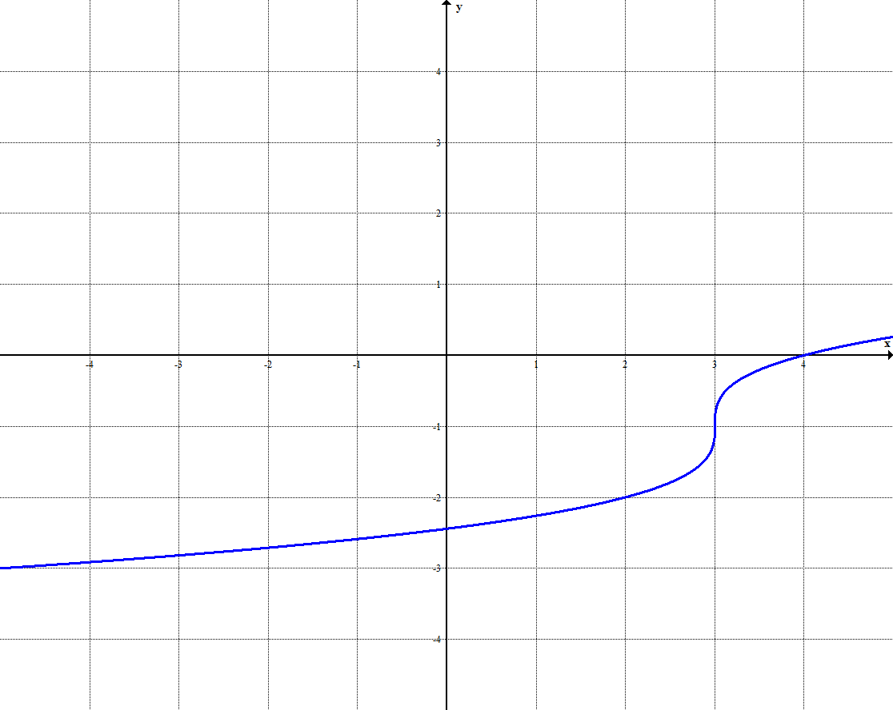
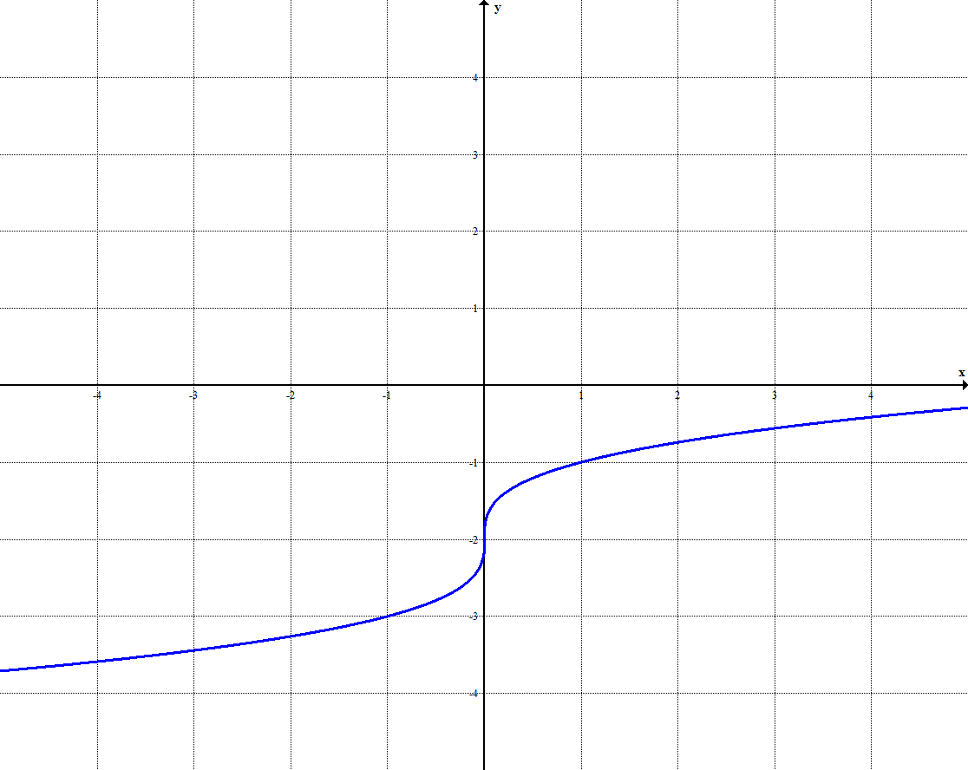

11. Which of the following functions has its inflection point in Quadrant 1?

A. $f\left(x\right)=\sqrt[3]{x+1}-1$ B. $f\left(x\right)=\sqrt[3]{x+1}+1$

C. $f\left(x\right)=\sqrt[3]{x-1}+1$ D. $f\left(x\right)=\sqrt[3]{x-1}-1$

