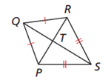**Guided Practice**

In kite PQRS, m ∠PQR=78°, and m ∠ TRS=59°. Find each measure.

1. m ∠QRT 2. m ∠QPS 3. m ∠PSR

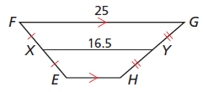 4. Find m ∠ F. 5. JN = 10.6, and NL = 14.8. Find KM 6. Find EH.

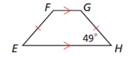 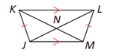

**Practice Problems**

**Fill in the blanks to complete each theorem or definition. (Use your notes.)**

7. If a quadrilateral is a kite, then its _______________________ are perpendicular.

8. If a quadrilateral is a kite, then exactly one pair of opposite _________________ are congruent.

9. A kite is a quadrilateral with exactly two pairs of congruent consecutive ____________________.

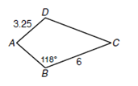**ABCD is a kite. Use the figure to find each measure in problems 10-12.**

10. m ∠D 11. AB 12. CD

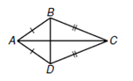**In kite ABCD, m** ∠**BAC = 35° and m** ∠**BCD = 44°. For problems 13-15, find each measure.**

13. m ∠ABD 14. m ∠DCA 15. m ∠ABC

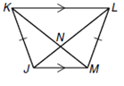16. Find m ∠Z. 17. KM = 7.5, and NM = 2.6. Find LN.

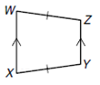

82**°**

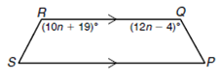18. Find the value of n so that PQRS is isosceles.

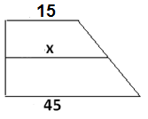19. Find t. 20. Find X.

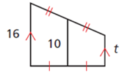

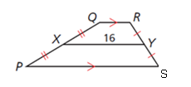

21. In trapezoid PQRS, what could be the lengths of QR and PS?

A. 6 and 10 C. 8 and 32

B. 6 and 26 D. 10 and 24

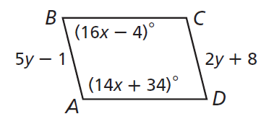Review

**ABCD is a parallelogram. Find each measure.**

**Use the picture on the right for problems 22-23.**

22. CD 23. m ∠C

3

24. m∠1 __________ m ∠2 _______ m ∠3 ________

5

4

2

1

21°

m ∠4 ______ m ∠5 _______