_________________________________ Unit 6 Day 3 Assignment

**Guided Practice**

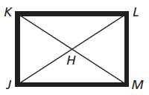A woodworker constructs a rectangular picture frame so that JK = 50 cm and JL = 86 cm. Find the measures.

1. HM 2. KL (to the nearest cm)

C

A

B

D

1

2

3

4

5

3. Use the rhombus to find the numbered angles. mBCD = 108

1 = _____ 2 = _____ 3 = _____

4 = _____ 5 = _____

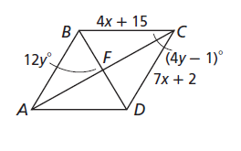**ABCD is a rhombus. Find each measure**.

4. AB 5. mACB

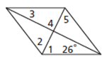**Find the measures of the numbered angles in each figure.**

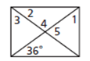6. Rhombus 7. Rectangle

1 = _____ 3 = _____ 5 = _____ 1 = ____ 3 = _____ 5 = ____

2 = _____ 4 = _____ 2 = ____ 4 = _____

**Practice and Problem Solving**

Find the measure of the numbered angles in each rectangle and square.

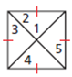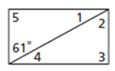8. 1 = _____ 4 = _____ 9. 1 = _____ 4 = _____

2 = _____ 5 = _____ 2 = _____ 5 = _____

3 = _____ 3 = _____

Find the measure of the numbered angles in each rhombus.

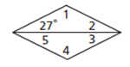10. 1 = _____ 4 = _____ 11.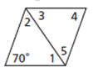 1 = _____ 4 = _____

2 = _____ 5 = _____ 2 = _____ 5 = _____

3 = _____ 3 = _____

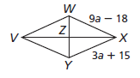VWXY is a rhombus. Find each measure.

12. VW = ________

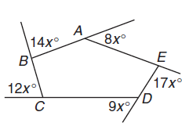13. mXZW = (10b – 5) b = ________

Review

14. Find the measure of x in pentagon ABCDE.

15. Find the measure of each exterior angle in pentagon ABCDE.

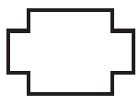Tell whether each figure is a polygon and if it is concave or convex.

16. 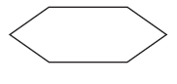 17.

18. Find the measure of each interior angle of a regular nonagon.

19. What is the sum of the measures of the interior angles of a pentagon?

20. What is the measure of each exterior angle of a hexagon?