______________________________ Assignment Unit 5 Day 7

**Guided Practice**

1) An angle of __?__ is measured from a horizontal line to a point above that line.

(*elevation* or *depression*)

2) An angle of __?__ is measured from a horizontal line to a point below that line.

(*elevation* or *depression*)

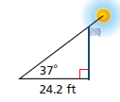3) When the angle of elevation to the sun is 37, a flagpole

casts a shadow that is 24.2 ft long. What is the height of

the flagpole to the nearest foot?

4) The pilot of a traffic helicopter sights an accident at an angle of depression of 18.

The helicopter's altitude is 1560ft. What is the horizontal distance from the

helicopter to the accident? Round to the nearest foot.

**Practice and Problem Solving**

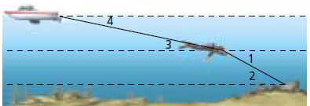Classify each angle as an angle of elevation or depression.

5) 1 6) 2

7) 3 8) 4

9) A plane is at an altitude of 3500 ft and the angle of elevation from the airport to the plane

is 29. What is the horizontal distance to the nearest foot between the plane and the

airport?

10) A forest ranger in a 90-foot observation tower sees a fire. The angle of depression is 3.

What is the horizontal distance (nearest foot) to the fire?

11) The Seattle Space Needle casts a 67 m shadow. If the angle of elevation from the tip of

the shadow to the top of the Space Needle is 70, how tall is the Space Needle (to the

nearest meter)?

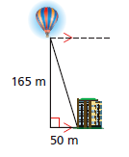12) An observer in a hot-air balloon sights a building that is 50 m from the balloon's launch point. The balloon has risen 165 m. What is the angle of depression from the balloon to the building? (nearest degree)

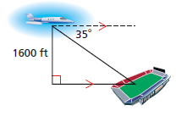13) Mai is flying a plane at an altitude of 1600 ft. She sights a stadium at an angle of 35.

What is Mai's approximate horizontal distance from the stadium?

A) 676 feet C) 1450 feet

B) 1120 feet D) 2285 feet

14) Jeff finds that an office building casts a shadow that is 93 ft long when the angle of

elevation to the sun is 60. What is the height of the building?

A) 54 feet B) 81 feet C) 107 feet D) 161 feet

Review

Solve each proportion.

15)  16)  17) 

18) What is needed to use the tangent of an angle? A) opposite leg and hypotenuse B) opposite leg and adjacent leg C) adjacent leg and hypotenuse

19) Which trig ratio is defined as $\frac{adjacent leg}{hypotenuse}$? A) sine B) tangent C) cosine

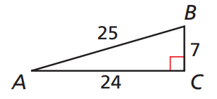20) Which is equal to the sine of A? A) 0.96 B) 0.33 C) 0.28 D) 3.57

21) Which is equal to the tangent of B?

A) 0.28 B) 3.43 C) 0.29 D) 1.04