______________________________ Assignment Unit 5 Day 5

Guided Practice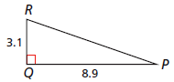

**Find the unknown angle measures to the nearest degree.**

1) mR = 2) mP =

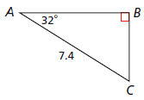

**Find the unknown lengths to the nearest hundredth.**

3) AB 4) BC

5) A hill in the Tour de France bike race has a grade of 8%. To the nearest degree, what is the angle that this hill makes with a horizontal line?

6) For maximum accessibility, a wheelchair ramp should have a slope between  and .

What is the range of angle measures that a ramp should make with a horizontal line?

Round to the nearest degree.

**Practice and Problem Solving**

**Use your calculator to find each angle measure to the nearest degree.**

7) tan(2.1) 8) cos() 9) sin(0.5)

10) sin(0.31) 11) tan(1) 12) cos(0.8)

**Use your calculator to find each trig ratio. Round to the nearest hundredth.**

13) sin 45 14) cos 45 15) tan 30

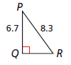

**Find the unknown angle measures to the nearest degree.**

16) mR = 17) mP =

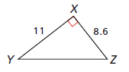

18) mY = 19) mZ =

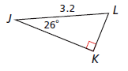

**Find the unknown lengths to the nearest hundredth.**

20) JK 21) LK

22) A highway exit ramp has a slope of . To the nearest degree, find the angle that the

ramp makes with a horizontal line.

23) As part of off-season training, the Houston Texans football team must sprint up a ramp

with a 28% grade. To the nearest degree, what angle does this ramp make with a

horizontal line?

24) To the nearest degree, what is the measure of the acute angle

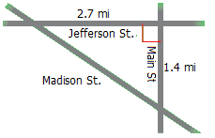 formed by Jefferson St. and Madison St?