____________________________ Assignment Unit 5 Day 3

**Guided Practice**

Find the missing sides of each special right triangle. Leave answers in simplest radical form.

a

a

45

16

1. 2. 3.

b

b

45

16

a

10

c

45

a =_______ c = _______ a = _______ b = ______

60

30

a

c

15

30

60

20

a

b

30

60

15

a

c

4. 5. 6.

a = _______ a = _______ a = _______

b = _______ c = _______ c = _______

**Practice and Problem Solving**

Find the missing sides of each special right triangle. Leave answers in simplest radical form.

A M N P T 45

45  45

12 R

45 Q

45 B O

C 6.3 R S

45°

45

45

8

7. 8. 9. 10.

AC = MN = PR = RS = AB = MO = QR = TS =

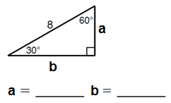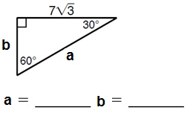11. 12. 13.

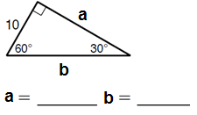

a

14. 15. 16. 17.

30

G

H

K

60

30

O

M

N

60

15

D

E

F

60

30

11

A

C

B

60

30

18

4.2

AC = DE = GK = NO =

CB = FE = HG = MN =

Review

Tell whether a triangle can have sides 20. Find the value of x. Round your answer to

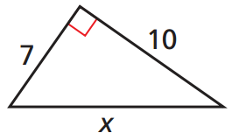with the given lengths. If so classify the the nearest hundredth.

triangle as acute, obtuse, or right.

18. 4, 7.5, 8.5 19. 7, 9, 18

21. Find x. 22. Find x and simplify the radical.

8

16

**x**

**x**

11

61