______________________________ Assignment Unit 5 Day 2
Guided Practice
x
24
51
Find x:
x
11
61
1) 2)

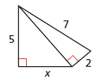
3) Find x. Simplify the radicals 4) Find the variables. Round to the nearest tenth.
8
16
x

y

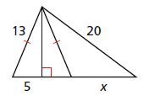
5) Find the variables.

y

Practice and Problem Solving
Find x.
6
10
x
x
15
12
6) 7) 8)
x
26
24

Find x. Simplify radicals.
14
7
x
9)

Find x. Round to the nearest tenth.
10) 11)
2
7
x
x
9
13

Find the variables. Round to the nearest tenth
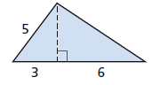
12) 13)
8
8
6
x
y
y
x

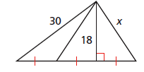
14)
y
y
y

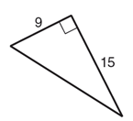
Find the missing side length in each triangle.
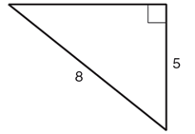
15) 16)

