_________________________ Unit 4 Day 9 Assignment

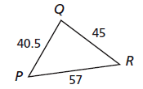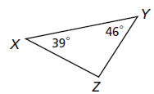

**Guided Practice**

1) Write the angles in order 2) Write the sides in order

from smallest to largest. from shortest to longest.

**____________________ _____________________**

3) The lengths of two sides of a triangle are given. Find the range of possible lengths for the third side.8 mm, 12 mm **____________________**

**For the next two problems draw a picture for each.**

4) In △DEF, DE = 8 in, EF = 6 in 5) In △ABC, if mC < mB < mA,

and DF = 10 in. Which lists the then----

angles in order from smallest to F. AB < AC < BC

largest? G. AC < AB < BC

A. D, E, F B. F, D, E H. AB < BC < CA

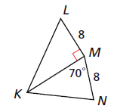 C. E, F, D D. D, F, E J. BC < AB < CA

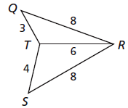**Compare the given measures.**

6) mSRT and mQRT 7) KL and KN

**__________________ __________________**

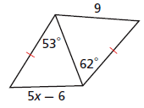**Find the range of values for *'x' for problem 8.***

8) **__________________**

**Practice and Problem Solving**

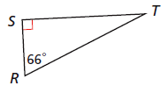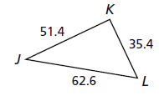9) Write the angles in order 10) Write the sides in order

from smallest to largest. from shortest to longest.

**_______________________ ______________________**

**Tell whether a triangle can have sides with the given lengths (yes or no). Explain.**

11) 6, 10, 15 **__________** 12) 14, 18, 32**__________** 13) 5.8, 5.8, 11.9 **__________**

14) 4, 7, 10 **_________** 15) 2, 9, 12**_________** 16) 3, 3, 6 **__________**

**The lengths of two sides of a triangle are given. Find the range of possible lengths for the third side.**

17) 4 yd, 19 yd **_____________________**  18) 9.2 cm and 3.8 cm**___________________**

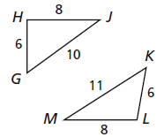

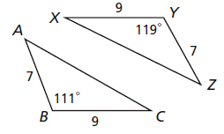**Compare the given measures.**

19) AC and XZ 20) mGHJ and mKLM

**__________________**  **__________________**

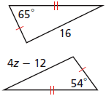**Find the range of values for '*z*'.**

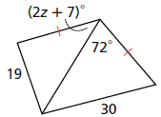21) **__________________** 22) **__________________**

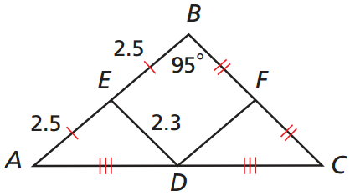Review

23)  is a midsegment of △ABC. What is the measure of DFC?

24) Find BC.