Assignment: Solving Quadratic Equations Using the Square Root Property
Name ________________________________
Date ___________________ Period ________
Solve. Show Work!
1. $x^{2}=121$ 8. $x^{2}=10$${\left(x-5\right)}^{2}=20$

2. $x^{2}-16=0$ 9. $x^{2}=-28$${\left(x-8\right)}^{2}=-144$

3. $x^{2}+8=0$ 10. $5x^{2}-100=0$${\left(x-7\right)}^{2}+4=48$

4. $x^{2}-10x+25=20$ 11. $x^{2}+4x+4=-6$${\left(x+2\right)}^{2}+10=4$

5. $x^{2}-16x+64=-144$ 12. $2x^{2}-24x+72=36$$5{\left(x-9\right)}^{2}=45$

6. $x^{2}-14x+49=44$ 13. ${-5x}^{2}-60x-180=10$$-5{\left(x+6\right)}^{2}=10$

7. $x^{2}-4x+4=49$ 14. $5x^{2}+90x+405=45$$16{\left(x-2\right)}^{2}-12=-60$

15. Solve using the square root principle: $x^{2}+14x+49=5$

A $x=-7±\sqrt{5}$ B $x=±2\sqrt{3}$

C $x=±7\sqrt{5}$ D $x=7±\sqrt{5}$

16. A square is increased by 4 inches on each side. If the new area is 36 in², what was the length of a side of the original square?

Graph.
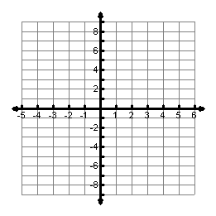
17. $f\left(x\right)=2{\left(x+1\right)}^{2}-2$ 18. $f\left(x\right)=-{\left(x-2\right)}^{2}+4$

Vertex:
Axis of Sym:
Domain:
Range:
Solutions:
Max/Min
Vertex:
Axis of Sym:
Domain:
Range:
Zeros:
Max/Min

