Assignment: Solving Square Root Equations

Name ________________________________

Date ___________________ Period ________

**Graph and solve. Show Work!**

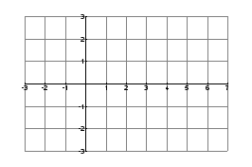1. $2\sqrt{x+1}=2$ Solve: $2\sqrt{x+1}=2$

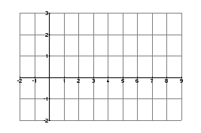2. $-\sqrt{x-1}=-2$ Solve: $-\sqrt{x-1}=-2$

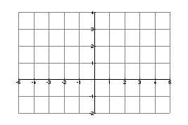3. $\sqrt{x+3}=-1$ Solve: $\sqrt{x+3}=-1$

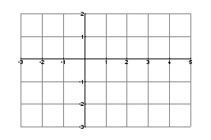4. $\sqrt{x+2}=2$ Solve: $\sqrt{x+2}=2$

**Solve each of the following equations. Show Work!**

5. 6. 7.

8. 9. 10.

11. 12. 13.

14. 15. 16.

17. 18. 19.