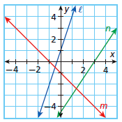_________________________________ Assignment Unit 4 Day 6

**Guided Practice**

**Write a ratio expressing the slope of each line.**

1. l 2. n

3. The ratio of the side lengths of a quadrilateral is 2:4:5:7, and its perimeter is 36 m.

What is the length of the shortest side?

5. Determine whether the polygons are similar. If so, write the similarity ratio and a similarity statement.

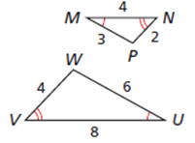4. Identify the pairs of congruent angles and corresponding sides.

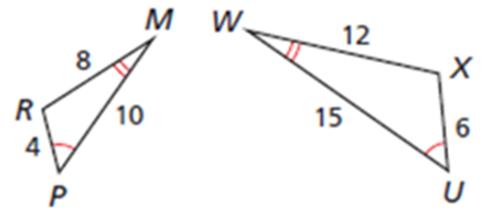

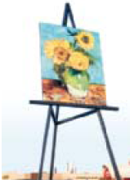

6. The town of Goodland, Kansas claims that it has one of the world's largest easels. It holds an enlargement of a Van Gogh painting that is 24 ft. wide. The original painting is 58 cm wide and 73 cm tall. If the reproduction is similar to the original, what is the height of the reproduction to the nearest foot?

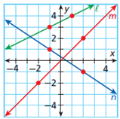

**Practice and Problem Solving**

**Write a ratio expressing the slope of each line.**

7. l 8. m 9. n

**Solve each proportion.**

10.  11.  12.  13.

14. The ratio of the side lengths of an isosceles triangle is 4:4:7 and its perimeter is

52.2 cm. What is the length of the longest side of the triangle?

15. An 18-inch stick breaks into three pieces. The ratio of the lengths of the pieces is

1:4:5. Which of these is NOT a length of one of the pieces?

A) 1.8 in B) 3.6 in C) 7.2 in D) 9 in

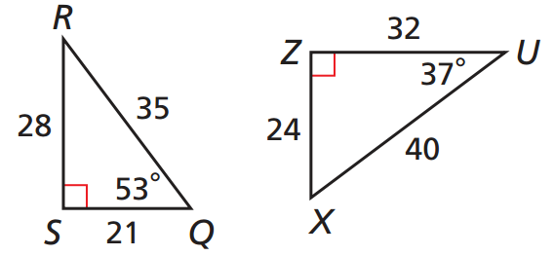

16. Determine whether the polygons are similar. If so, write the similarity ratio and a similarity statement.

(Remember that angles of a triangle add up to 180°)

17. The Arkansas State Capitol Building is a smaller version of the U.S. Capital. The U.S. Capital is 752 ft long and 288 ft tall. The Arkansas Capital is 564 ft long. What is the height of the Arkansas State Capital?

18. The ratio of the model car's dimensions to the actual car's dimensions is . The model has a length of 3 in. What is the length of the actual car?

19. Which value of y makes the 20. △CGL ~△MPS.

two rectangles similar? The similarity ratio of △CGL to

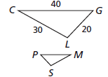A) 3 △MPS is . What is the length of ?

B) 8.2

C) 25.2 A) 8

D) 28.8 B) 12

C) 50

D) 75