____________________________ Assignment Unit 4 Day 3

**Guided Practice**

1) If △ABC  △RST, what angle corresponds to S? ___________

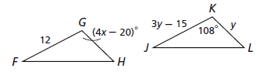

**Given:** **△FGH**  **△JKL. Find each value.**

2) KL = ____________ 3) *x* = _____________

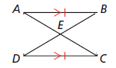

4) Given: E is the midpoint of  and 

,  ll 

Prove: △ABE  △CDE

1)  ll  1)_______________________

2) ABECDE, BAE DCE 2)_______________________

3)  3)_______________________

4) E is the midpoint of  and  4)_______________________

5) _________________________ 5) Definition of Midpoint

6) AEB CED 6)_______________________

7) △ABE  △CDE 7)_______________________

**Practice and Problem Solving**

**Given: △XYZ  △HIJ. Identify the congruent corresponding parts.**

5) __________ 6) _________ 7) _________

8) __________ 9) _________ 10) _________

**Given: Polygon CDEF  polygon KLMN. Identify the congruent corresponding parts.**

11) _________ 12) _________

13) F  _________ 14) L  _________

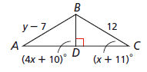

**Given: △ABD  △CBD. Find each value.**

15) mC = ___________ 16) *y* = ___________

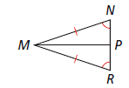17)Given: bisects NMR, P is the midpoint of ,

MP

, N R

Prove: △MNP △MRP **Answer choices (Given may be** 1) N R 1) __________ **used more than once)**

MP

2) bisects NMR 2) __________ A) Given

3) ________ 3) Def of bisect B) 

4) ________ 4) Third s Thm C) Reflexive

5) P is the midpoint of  5) __________ D) NMP  RMP

6) ________ 6) def of midpt E) MPN  MPR

7)  7) __________ F) Def of △s

8)  8) __________

9) △MNP △MRP 9) __________

18) Polygon ABCD  polygon PQRS, BC = 6x + 5, and QR = 5x + 7.

x = __________ BC = ________

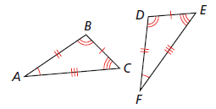

19) Which congruence statement correctly indicates

that the two given triangles are congruent?

A) △ABC  △EFD C) △ABC  △DEF

B) △ABC  △FDE D) △ABC  △FED

20) △ABC  △XYZ. mA = 47.1°, and mC = 13.8°. Find mY.

A) 13.8° C) 76.2°

B) 42.9° D) 119.1°

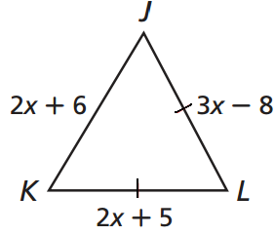

Review

22) What is the classification of the given triangle?

A) scalene right B) isosceles obtuse

C) equiangular acute D) scalene obtuse

21) What is JL?

A) 62

B) 31

120°

C) 27

D) 54

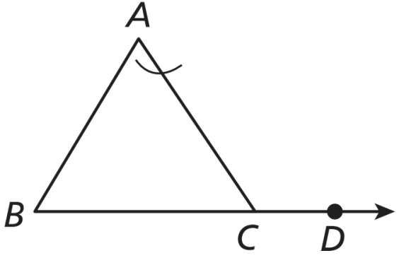

23) What is the mACD? A) 95° B) 85° C) 113° D) 99°

65°

30°