# __________________________ Assignment Unit 4 Day 2

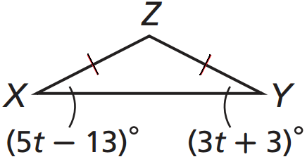**Guided Practice**

Find each measure.

1) mECD = __________ 2) mX = __________

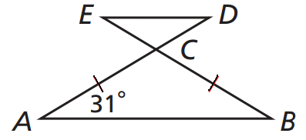

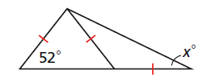

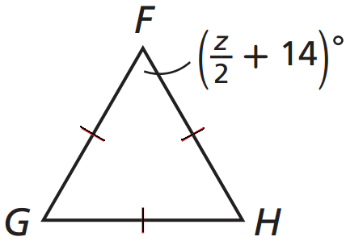

3) z = _________ 4) x = _________

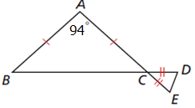

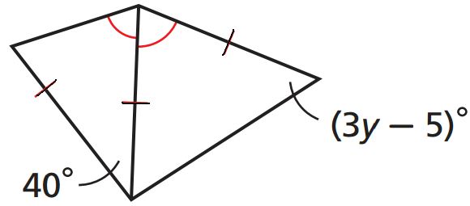5) mE = __________ 6) y = __________

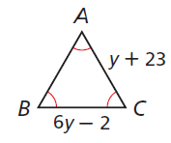**Practice and Problem Solving**

Find each measure.

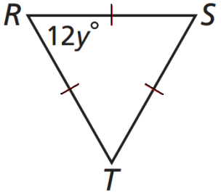

7) y = __________ 8) BC = _________

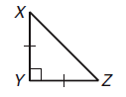

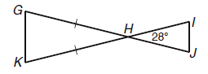9) mX = __________ 10) mK = __________

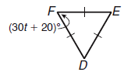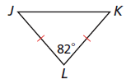

11) t = _________ 12) mK = _________

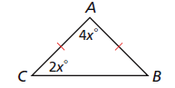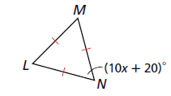

13) x = __________ 14) x = ___________

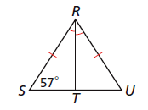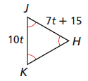

15) JK = __________ 16) mTRU = _________

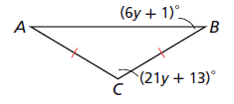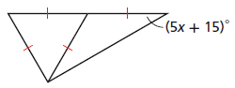17) x = __________ 18) mA = __________

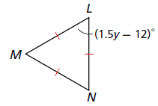19) y = _________

20) n = _________

