____________________________ Assignment Unit 4 Day 1

1

4

2

3

5

**Guided Practice**

**What are the remote interior angles for the given exterior** **angle?** 1) 4

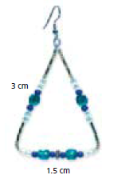

2) A jeweler creates triangular earrings by

bending pieces of silver wire. Each earring

is an isosceles triangle with the dimensions

shown. How many earrings can be made

from a piece of wire that is 50 cm long?

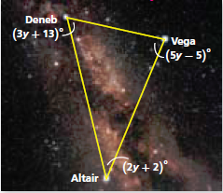

3) An *asterism* is a group of stars that is easier to recognize than a

constellation. One popular asterism is the Summer Triangle, which is

composed of the stars Deneb, Altair, and Vega. What is the value of *y*?

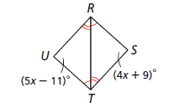

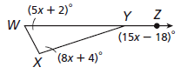**Find the value of the variables.**

4) x = __________ 5) x = __________

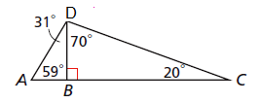

**Practice and Problem Solving**

**Classify each triangle by its angle measures.**

(acute, right, obtuse, and equiangular)

6) △DBC 7) △ADC

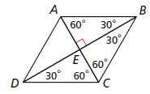

8) △BEA 9) △ABC

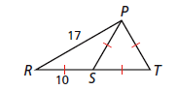

**Classify each triangle by its side lengths.** (scalene, isosceles, and equilateral)

10) △PST 11) △PSR 12) △RPT

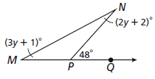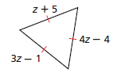**Find the value of each variable.**

13) z = __________ 14) y = __________

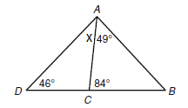

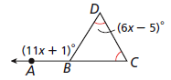**Find the value of each variable.**

15) x = __________ 16) x = _____________

Two angles of a triangle are given. What is the measure of the third angle? Then classify the triangle as **acute**, **right**, or **obtuse**.

17) 34, 42, ________ 18) 28, 85, ________ 19) 23, 67, ________

____________ _____________ _____________

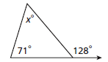20) What is the value of *x*?

A) 19 C) 57

B) 52 D) 71