____________________________ Assignment Unit 3 Day 5

1

2

3

4

5

6

7

8

l

m

**Guided Practice**

**Name the postulate or theorem that proves l ll m.**

1) 8 6 2) 8 4 3) 2 6

4) m2 + m3 = 180

**Determine which lines, if any, are parallel using the given information.**

1

2

3

4

5

6

7

8

9

10

11

12

13

14

15

16

m

n

a

b

**Justify your answer.**

5) 5 4 6) 13 15

7) 5 10 8) 6 11

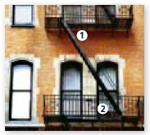

9) In the fire escape, m1 = (17x + 9), m2 = (14x + 18),

and x = 3. Show that the two landings are parallel.

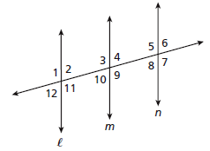

**Practice and Problem Solving**

**For the given information, tell which pair of lines must by parallel. Name the postulate or theorem that supports your answer.**

10) m2 = m10 11) 1 7 12) 10 6

13) 11 5 14) m2 + m5 = 180 15) m8 + m9 = 180

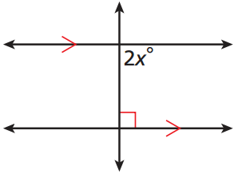

**Solve to find *x* in each diagram.**

16) 17)

(5x + 4)

19) Lines l and m are cut by transversal n. Which statement would prove l ll m?

A) m2 = m6 B) m7 + m8 = 120 C) m2 = m3 D) m3 + m5 = 90

18) Transversal *t* cuts lines *a*, *b*, *c*, and *d.*

Which two lines are parallel?

A) *a* and *c*

B) *a* and *d*

C) *b* and *c*

D) *b* and *d*

2

1

3

4

5

6

7

8

l

m

n

*b*

*a*

*c*

*d*

105

75

85

100

*t*

d

j

k

l

m

91

79

89

89

20) Line d is a transversal. For lines j, k, l, m, which three lines are parallel?

A) d, j, and k B) l, m, and k

C) k, l, and j D) l, m, and j

Review

21) Which segment is perpendicular to?

A)  B) 

C)  D) 

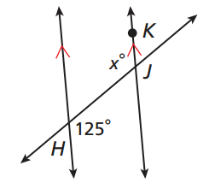

22) What is the value of x?

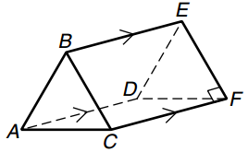

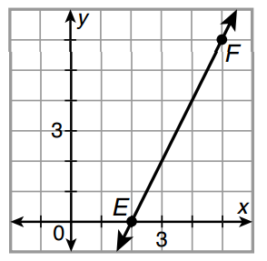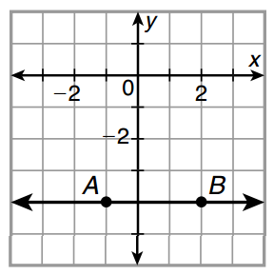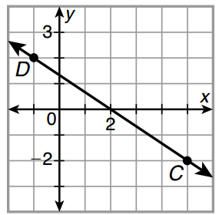**Determine the slope of the line.**

23) 24) 25)