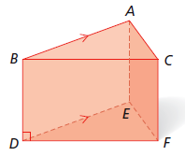______________________ Assignment Unit 3 Day 4

**Guided Practice**

**Identify each of the following.**

1) one pair of perpendicular segments

2) one pair of parallel planes

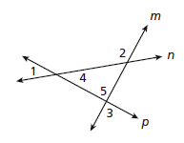

**Identify the transversal and classify each angle pair.**

3) 1 and 2 4) 2 and 3

5) 2 and 4 6) 4 and 5

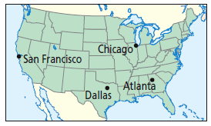7) Describe the type of lines formed by two planes when

flight 1449 is flying from San Francisco to Atlanta at

32,000 feet and flight 2390 is flying from Dallas to

Chicago at 28,000 feet.

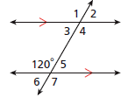**Use the 120 to find each angle measure.**

**Justify each answer with a postulate or theorem.**

8) m1 9) m4

10) m7 11) m3

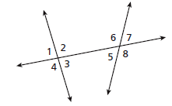**Practice and Problem Solving**

**Identify the angle pair.**

12) 2 and 6 13) 1 and 8

14) 1 and 6 15) 2 and 5

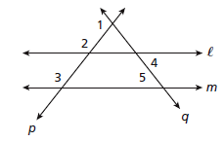**Identify the transversal and classify each angle pair.**

16) 2 and 3 17) 4 and 5

18) 2 and 4 19) 1 and 2

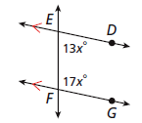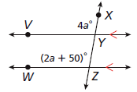**Find the value of the variable.**

20) a 21) x

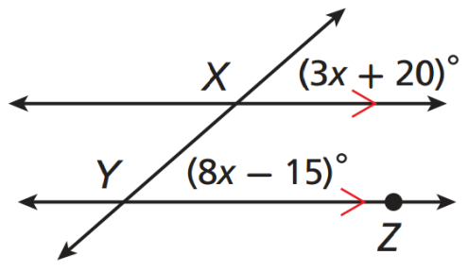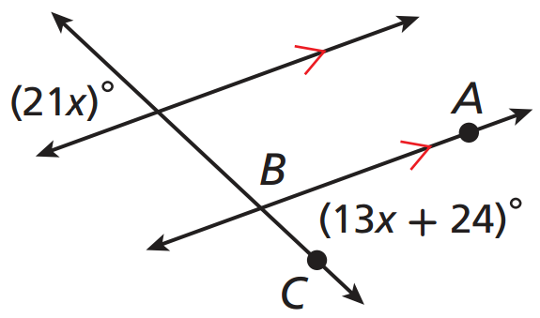22) x 23) x

**REVIEW**

25) Write the equation of the line through (-5, 4) with slope in point-slope form.

24) Use slopes to determine whether the lines are parallel, perpendicular, or neither JK where J(4, 3), K(5, -1), and LM where L(-2, 4), and M(3, -5).