__________________________ Assignment Unit 3 Day 1

**Guided Practice**

1) **Find the next item in the pattern:** , , , ... _____________

2) **Complete the conjecture:** The product of two even numbers is ______________.

**Show that the conjecture is false by finding a counterexample.**

3) Three points on a plane always form a triangle.

4) If two planes intersect, then they intersect in exactly one point.

**Identify the *hypothesis* and *conclusion* of the conditional.**

5) A figure is a parallelogram if it is a rectangle.

**Write a conditional statement from the following.**

6) After three strikes, the batter is out.

7) Congruent segments have equal measures.

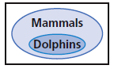8)

**Practice and Problem Solving**

**Find the next item in each pattern.**

9) March, May, July, ... ___________ 10)

_____________

11) **Complete the conjecture:** The square of any negative number is ______________.

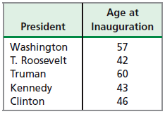**Show that the conjecture is false by finding a counterexample.**

12) Kennedy is the youngest U.S. president to be inaugurated.

**Identify the *hypothesis* and *conclusion* of each conditional.**

13) If a person is at least 16 years old, then the person can drive a car.

14) Four angles are formed if two lines intersect.

15) If an animal is a tabby, then it is a cat.

**Write a conditional statement from the following.**

16) Eighteen-year-olds are eligible to vote.

17) 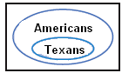

**Show that the conjecture is false by finding a counterexample.**

18) If the season is spring, then the month is March.

19) If an angle is acute, then it has a measure of 30°.

**Review**

A

D

E



B

**Find the measure of the angles using the protractor.**

20) ∠DEC

C