**Unit 2 Review**



1.) Plot each point on the coordinate plane to the right.

A(-1, 2) B(5, 3) C(-3, -4) D(4, -2)

2.) What is the coordinate for each of the following points



B

C

A

D

located on the coordinate plane?

A( , ) B( , )

C( , ) D( , )

3.) Find the midpoint of . (___, ___)

4.) M is the midpoint of , and M has coordinates (-2, 1). A has coordinates (1, 0). Find the coordinates of B.

B(___, ___)



B

A



5.) Find the coordinates of the midpoint of  with endpoints A(3, 2) and B(-1, 9).

(___, ___)

Use the distance formula to find the distance between the given points to the nearest tenth.

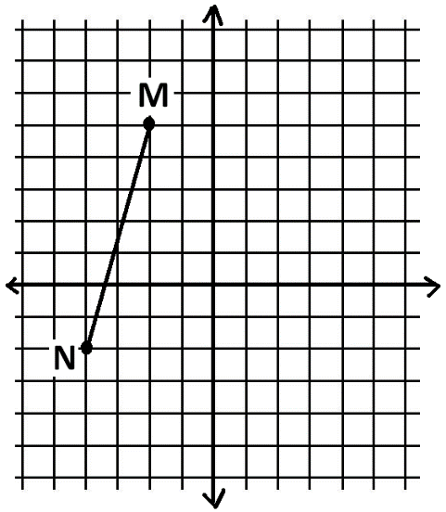6.) R(-1, 4) and S(0, 8) 7.) T(5, 1) and U(-1, 3)

8.) Use the distance formula or Pythagorean Theorem to find the length of the segment (Round to the nearest tenth).

9.) Andrew has a rectangular poster that is

10.) Determine if AB CD. (You need to

find the length of AB and CD.)



A

B

C

D

8ft tall and 4ft wide. He would like to separate

the poster into two sections by creating a

diagonal from one corner of the poster to the

opposite corner. Find the length of the diagonal

to the nearest foot.

11.) Identify the types of slope shown below in each graph.

(positive, negative, zero, and undefined)

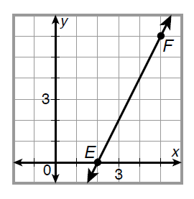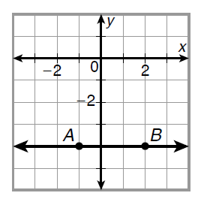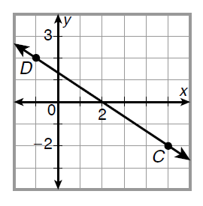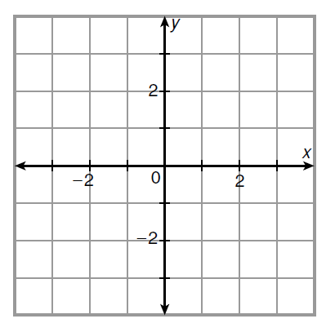

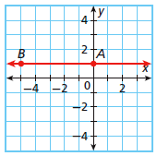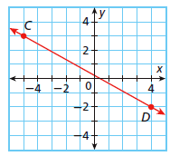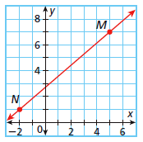Determine the slope of each line:

12.) 13.) 14.)

Use slopes to determine whether the lines are **parallel**, **perpendicular**, or **neither.**

15.)  and  for H(3,2), J(4,1), K(-2,-4), and M(-1,-5)

16.)  and  for L(-2,2), M(2,5), N(0,2), and P(3,-2)

17.) What is the equation of the line through (2, 4) with slope in **point-slope** form?

1

2

18.) What is the equation of the line through (0, 2) and (-2, 8) in **slope-intercept** form?

Determine whether the lines are **parallel**, **intersect**, or **coincide**.

1

5

19.) 5x – y = 0 and y = x 20.) y = x – 1 and y = x + 8 21.) y = 2x – 1 and y = 2x – 1

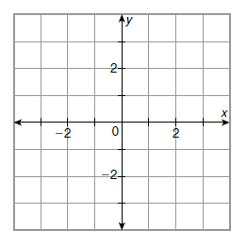Graph each line.

22.) y = -2 23.) y = -x + 2 24. y = 3x – 2