_____________________ Assignment Unit 2 Day 3 Slope

**Guided Practice**

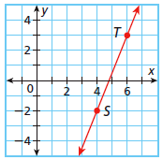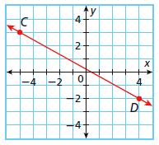 **Determine the slope of each line.**







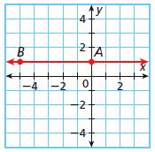

1) CD 2) AB 3) ST

**Use slopes to determine whether the lines are parallel, perpendicular, or neither.**





4) HJ and KM for H (3,2), J (4,1), K (-2, -4), and M (-1, -5)

**Practice and Problem Solving**

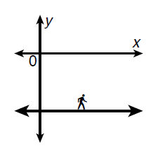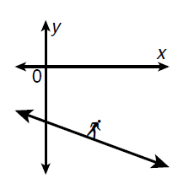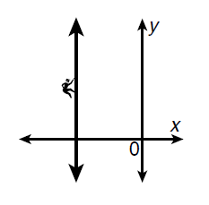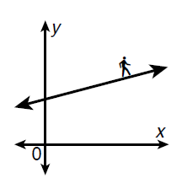**Tell what type of slope each of the lines with the hiker have. (positive, negative, zero, or undefined)**

5) 6) 7) 8)

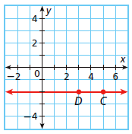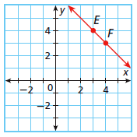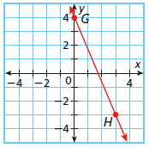**Determine the slope of each line.**







9) CD 10) EF 11) GH

**Use the slopes to determine whether the lines are parallel, perpendicular, or neither.**





12) AB and CD for A(2,-1), B(7,2), C(2,-3), and D(-3,-6)





13) XY and ZW for X(-2,5), Y(6,-2), Z(-3,6), and W(4,0)

14) JK and JL for J(-4,-2), K(4,-2), and L(-4,6)





Review

15) Find the coordinates of the midpoint of with endpoints W(-4, 1) and X(2, 9).

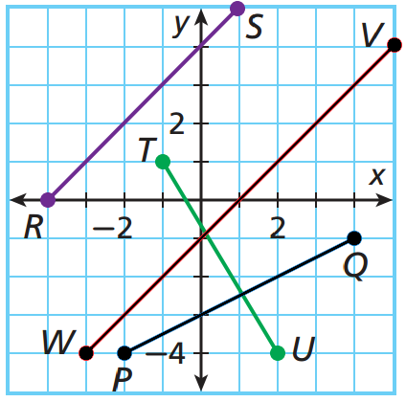16) Use the distance formula or Pythagorean Theorem to find the length of and and determine if they are congruent. Round to the nearest tenth.

17) Find the distance of  with endpoints A(3, 2) and B(-1, 4). Round to the nearest tenth.