**Guided Practice**

**Use the Distance Formula to find the distance between the points to the nearest tenth.**

1) V (2, -1) and W (-4,8)

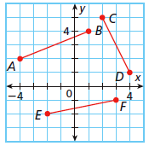**Use the Pythagorean Theorem to find the distance between the points to the nearest tenth.**

2) AB

3) CD

**Practice Problems**

**Use the Distance Formula to find the distance, to the nearest tenth, between each pair of points.**

4) A (1,-2) and B (-4,-4) 5) X (-2,7) and Y (-2,-8)

6) F (4, 3) to G (-3, -2). 7) F (-1, 6) to G (5, 2).

**Use the Pythagorean Theorem to find the length of each segment, to the nearest tenth.**

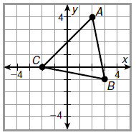

8) Find AB __________

9) Find BC __________

10) Find CA __________

11) Televisions and computer screens are usually advertised based on the length of their diagonals. If the height of a computer screen is 11 in. and the width is 14 in., what is the length of the diagonal? Round to the nearest inch.

Cedar City

**On the map, each square of the grid represents 1 square mile.**

12) Find the distance, to the nearest tenth of a mile, along

Highway 201 from Cedar City to Milltown. (The Highway is the line.)

Milltown

13) A coordinate plane is placed over the map of a town. A library is located at (-5,1), and a museum is located at (3,5). What is the distance, to the nearest tenth, from the library to the museum?

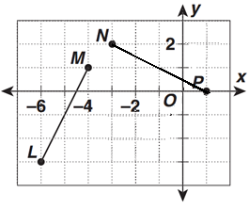

14. Find LM and NP using the distance formula or

Pythagorean theorem to the nearest tenth.

Then determine if .