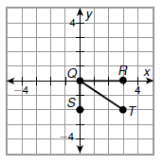**Guided Practice**

**Find the coordinates of the midpoint of each segment.**

1) Q(____,____) T(____,____)

midpoint of is ___________

2) B is the midpoint of . A has coordinates (-3, 4), and

B has coordinates (-1, 1). Use the graph to find the

coordinates of C(____,____)

3) X has coordinates (,), and Y has coordinates (,).

Find the coordinates of the midpoint of .

**Practice and Problem Solving**

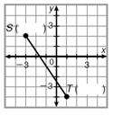**Find the coordinates of the midpoint of each segment.**

4) midpoint of  5) midpoint of  (_____,_____)

(_____,_____) A(4,-6) and B(-4,2)

**Find the coordinates of the midpoint of each segment.**

6)  with endpoints Y(4, 8) and Z(-1, -4) 7)  with endpoints X(,) and Y(, ).

(_____,_____) (_____,_____)

8) M is the midpoint of . L has coordinates (-2,0),

and M has coordinates (0,1). Use the graph to

find N(_____,_____)

9) M is the midpoint of . R has 10) M is the midpoint of . A has coordinates (-4, -2), and M has coordinates (1, 1). coordinates (2, -1), and M has Find the coordinates of S. coordinates (-1, 3). Find the coordinates of B.

.



11) What are the coordinates of the midpoint of a line

segment that connects the points (7,-3) and (-5,6)?

A) (6,-4) C) (2,)

B) (2,3) D) (1,1)