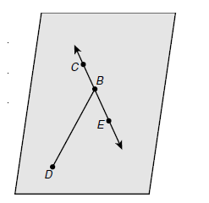
1. Name a plane. ____________
2. Name a segment. ____________
3. Name a line. ____________
4. Name three collinear points. ____________
5. Name three noncollinear points. ____________
6. Name the intersection of a line and a segment not on the line. ____________
7. Name a pair of opposite rays. ____________

Find each measure
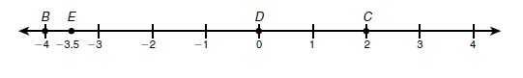
8. BE ____________ 9. DB ____________ 10. EC____________

11. A pole-vaulter uses a 15-foot-long pole. She grips the pole so that the segment below her left hand is twice the length of the segment above her left hand. Her right hand grips the pole 1.5 feet above her left hand. How far up the pole is her right hand.

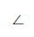
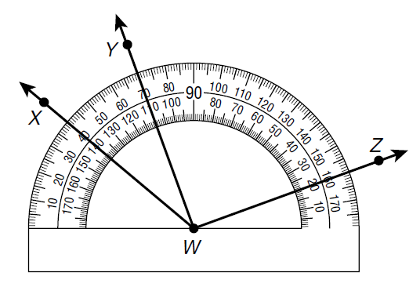
Find the measure of each angle and classify each as acute, right, obtuse, or straight.
12. ∠ YWZ ____________
____________
13. ∠ XWZ ____________
____________
14. Ray QT is in the interior of ∠PQR. Find m∠PQT
if m∠PQR = 25° and m∠RQT = 11°. _________

15. Find m ∠PQT if m ∠PQR = (10x – 7) °,
m∠RQT = 5x°, and m∠PQT = (4x + 6)°. ____________

16. Find m∠PQR if QT bisects ∠PQR,
m∠RQT = (10x – 13) °, and m∠PQT = (6x + 1) °. __________

17. Name the ray that angle PQR and angle SQR share. _________
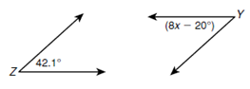
18. supplement of angle Z _______
19. complement of angle Y _______

20. ∠DEF and ∠FEG are complementary. m ∠DEF = (3x – 4),
and m ∠FEG = (5x + 6). Find the measures of both angles.

