___________________________ Assignment Unit 1 Day 6

**Guided Practice**

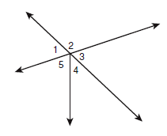**Tell whether the indicated angles are only *adjacent* (adj), are *adjacent* and form a *linear pair* (adj & LP), or *not adjacent* (not adj).**

1) 5 and 4 2) 1 and 4

3) 2 and 3 4) 1 and 3 are not adjacent or a linear pair. What is the relationship between 1 and 3?

**ABD and BDE are supplementary. Find the measure of both angles.**

5) mABD = 5xand mBDE = (17x - 18)

mABD = ________

mBDE = ________

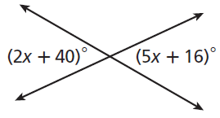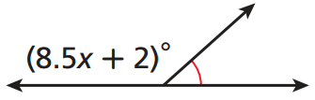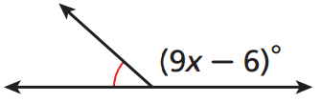

6) Find x. 7)Find x.

**Practice and Problem Solving**

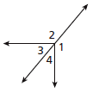**Tell whether the angles are only *adjacent*, *adjacent* and form a *linear pair*, or *not* *adjacent*.**

8) 1 and 4 _____________ 9) 2 and 3 ______________

10) 3 and 4 _____________ 11) 3 and 1 ______________

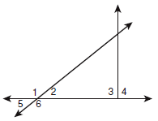

**Name each of the following.**

12) A pair of vertical angles ______________

13) A linear pair _______________________

14) An angle adjacent to 4_____________

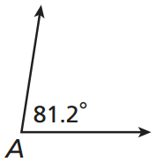

**Find the measure of each of the following.**

15) the complement of A 16) the supplement of A

**Given m****B = 56.4. Find the measure of each of the following.**

17) supplement of B 18) complement of B

19) ABD and DBC are complementary mABD = ________ mDBC = ________

mABD = (4y + 5)****

m DBC = (4y + 13)****

20) ABD and DBE are supplementary mABD = ________ mDBE = ________

mABD = (3x + 12)****,

mDBE = (7x - 32)****

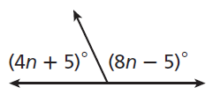**Find the variable for problem 21 and 22.**

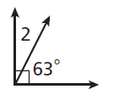

X

21) 22)

Review

23) D is in the interior ofABC. mABC =98****, and m ABD =13****. mDBC = ________. (Draw a figure)

24) Y is between X and Z, XY = 3x + 1, YZ = 2x - 2, and XZ = 84. XY = ________.

(Draw a figure)

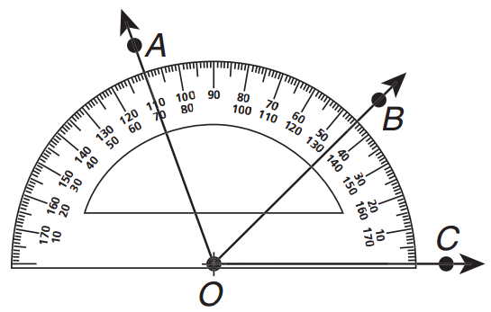

110

70

45

135

180

0

25) Classify AOC as *acute, right,* or *obtuse.* ________

Then use the protractor to find the mAOC. ________ (Hint: The measurements are written for you.)