__________________________ Assignment Unit 1 Day 5

**Guided Practice**

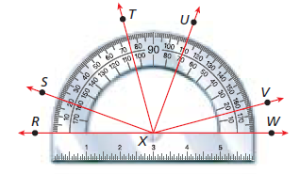**Classify each angle as *acute, right,* or *obtuse.* Then use the protractor to find the measure of each angle.**

1) VXW ________ 2) SXV ________

________ ________

3) Which point is the vertex of BCD? 4) Which rays form the sides of BCD?

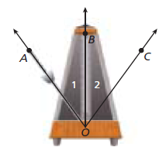

5) Musicians use a metronome to keep time as they play. The metronome’s

needle swings back and forth in a fixed amount of time. Name all of the

angles in the diagram.

**Ray BD bisects** **ABC. Find each of the following. (Draw figure a figure)**

6) mABD = (5y – 3)  and mDBC = (3y + 15) . m ABC = _______

Review

7) M is the midpoint of , PM = 2x + 5, and MR = 4x – 7. Solve for x. (Draw a figure)

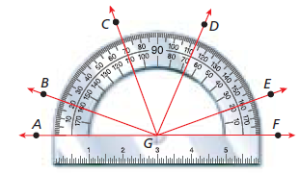**Practice and Problem Solving**

**Classify the angles as *acute, right* or *obtuse.***

**Then use the protractor to find the measure of the angle.**

8) CGE _________ _________

9) BGD _________ _________

10) AGB _________ _________

11) Which point is the vertex of LMT? 12) Which rays form the sides of DER?

***T* is in the interior of** **RSU. Find each of the following. (Draw figures)**

13) mRST = 38 and mTSU = 28.6 14) mTSU = 46.7 and mRSU = 83.5

mRSU = ________ mRST = ________

15) *T* is in the interior of PQR. mPQR = 84, mRQT = (2x – 2), and

mPQT = (3x + 1) . x = _________

16)  bisects JKM. mJKL = 42 17)  bisects ABC. mABD = (3x - 2) mJKM = ________ and mDBC = (9x – 26).

mABD = _________

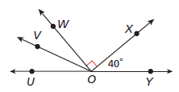

18) mUOW = 50, and  bisects UOW. What is mVOY?

Review

19) Q is between P and R, PR = 44 and PQ = 19. Draw a figure and solve for QR.

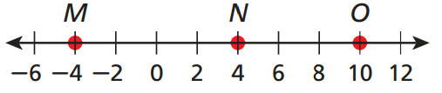

20) Find the length of MO.