__________________________ Unit 1 Day 4 Assignment

**Guided Practice**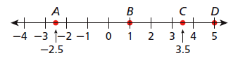

**Find each length.**

1) AB = _______ 2) BC = _______

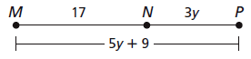3) B is between A and C, AC = 15.8, and 4) MP = _________

AB = 9.9. BC = _______ (Draw a figure)

5) K is the midpoint of . JL = 4x - 2, and 6) E bisects , DE = 2y, and EF = 8y - 3.

JK = 7. x = _______, KL = _______ DE = ________, EF = ________

JL = ________ (Draw a figure) DF = ________ (Draw a figure)

7) Jamilla has a piece of ribbon that is 48.5 cm long. For her scrapbook, she cuts it into two pieces so that one piece is 4 times as long as the other. What are the lengths of the pieces?

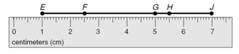**Practice and Problem Solving**

**Use the ruler to find each length.**

8) EG = ________ 9) FH = ________

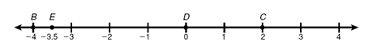**Find each length.**

10) DB = ________

11) EC = ________

**For exercises 12-15, H is between I and J. (Draw a figure for each problem)**

12) HI = 3.9 and HJ = 6.2. IJ = _______ 13) JI = 25 and IH = 13. HJ = _______

14) H is the midpoint of , and IH = 0.75. 15) H is the midpoint of , and IJ = 9.4.

HJ = ________ IH = ________

16) XY = _______ 17) LM = ________



18) B bisects , AB = 5, and AC = 3x + 1. (Draw a figure) x = ________

19) A carpenter has a wooden dowel that is 72 cm long. She wants to cut it into two pieces so that one piece is 3 times as long as the other. What are the lengths of the two pieces?



20) C is the midpoint of . B is the midpoint of . BC = 12.

What is the length of ?