­­­­­­__________________________ Assignment Unit 1 Day 3

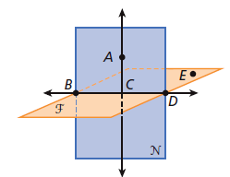**Guided Practice**

m

**Use the figure to name each of the following.**

1) five points 2) two lines

3) two planes 4) point on 

l

5) another name for Plane N 6) a ray opposite 

7) 3 collinear points 8) 4 coplanar points

9) 4 noncoplanar points 10) intersection of Plane F and Plane N

**Tell whether each statement is *sometimes, always,* or *never* true.**

11) If two planes intersect, they intersect in a straight line.

12) If two rays share a common endpoint, then they form a line.

**Practice and Problem Solving**

**Use the figure to name each of the following.**

13) three collinear points 14) three noncollinear points

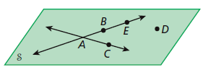

15) another name for Plane S 16) a ray opposite 

17) the intersection of  and 

**Use the figure to name each of the following. (Look at naming of points lines and planes.)**

m

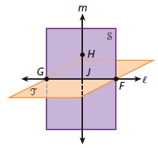18) three collinear points

19) four coplanar points

l

20) two points and a line that lie in Plane T

21) the intersection of Plane T and Plane S

**Tell whether each statement is *sometimes, always,* or *never* true.**

22) If two lines intersect, they intersect at two different points.

23)  is another name for 

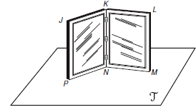

**Choose the best answer.**

24) A frame holding two pictures sits on a table.

Which is NOT a true statement?

A)  and  lie in plane T C)  and  intersect in a point

B)  and N intersect in a line D) P and  are coplanar

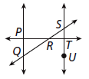

25) Which of the following is a set of noncollinear points?

A) P, R, T C) P, Q, R

B) Q, R, S D) S, T, U

26) Two flat walls meet in the corner of a classroom. Which postulate best describes this

situation?

A) Through any three noncollinear points there is exactly one plane.

B) If two points lie in a plane, then the line containing them lies in the plane.

C) If two lines intersect, then they intersect in exactly one point.

D) If two planes intersect, then they intersect in exactly one line.