_____________________________ Review Unit 1

D

E

C

A

B

R

n

m

Use the figure to name each of the following:

1) three collinear points 2) three noncollinear points

3) four coplanar points 4) a line in Plane R

5) a line that intersects Plane R 6) the point of intersection of the line from problem #5 and Plane R

7) a segment on line *n*

8) give another name for Plane R 9) a ray opposite EC

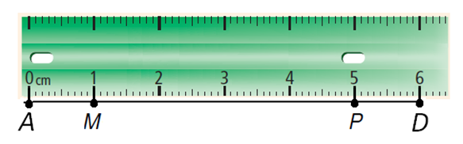

Use the ruler:

10) Find MP 11) Find MD

**X is between W and Y: (Draw a figure for each)**

12) WY = 15 and WX = 7.6, find XY.

13) WY = 20, WX = y and XY = 2y - 1, find y.

**S is the midpoint of : (Draw a figure for each)**

14) TS = 1.8, find SV.

15) TV = 19.7, find SV.

**D is between B and E**.

16) If BD=3x, DE= 3x+2, and BE=44. What is x?

17) If BD=6x – 8, DE=x, and BE=3x+21. What is BD?

18) Susan used a measuring tape to determine where three students should sit at a table. Susan needs to be located at the midpoint of the segment with Tim and Rachel on the ends. The distance between Tim and Susan is 4x - 7 and between Susan and Rachel is 5x - 15, draw a figure and find x.

19) ABC is shown to the right.

A

B

C

Which point is the vertex of ABC? ___________

Which rays form the sides of ABC? _________________

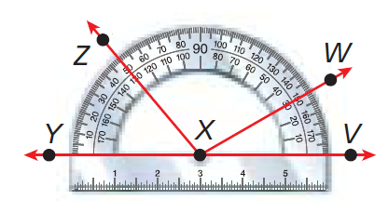Classify each angle as **acute**, **right**, **obtuse**, or **straight**. Then use the protractor to find the measure of:

20) WXV ­­_________

_________

21) ZXV ­­_________

_________

**For problems 22 and 23. F is in the interior of DEG. (Draw a figure for each)**

22) mFEG = 115 and mDEF = 48, find mDEG.

23) mDEF = (8x - 2), mFEG = (3x + 5) and mDEG = 146. Find x.

24)  bisects RTS. If mRTV = (16x - 6) and mVTS = (13x + 9), what is the measure of RTV? (Draw a figure)

Tell whether the angles are **adjacent (adj)**, **adjacent and form a linear pair (adj and LP)**, or **not adjacent (not adj):**

25) TSU and USV 26) TSU and XSV

R

S

T

U

V

X

1

2

27) RST and TSU 28) Name a pair of vertical angles.

29) A and B are complementary. If mA = 33, find mB.

30) M and N are supplementary. If mN = 54, find mM.

31) A and B are complementary. If mA = (3y + 18) and mB = 6y. Find mB.

32) ∠CDE and ∠EDF are supplementary. If m∠CDE=7x + 4⁰ and m∠EDF=2x + 14⁰. Find x and m∠CDE.

33) What is the value of n? 34) What is the value of x?

(2n + 8)

(4n - 2)

75

x