Assignment: Absolute Value Transformations $f\left(x\right)=a\left|x-h\right|+k$
Use transformations to graph the following equations. Fill in the requested information.
Name ________________________________
Date ___________________ Period ________

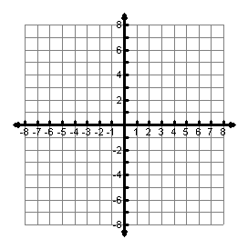
1. $f\left(x\right)=\left|x+5\right|$ 2. $f\left(x\right)=\left|x\right|-6$ 3. $f\left(x\right)=-3\left|x\right|$

Vertex: __________
Domain: __________
Range: __________
Max/Min: __________
x-intercept: __________
y-intercept: __________
Vertex: __________
Domain: __________
Range: __________
Max/Min: __________
x-intercept: __________
y-intercept: __________
Vertex: __________
Domain: __________
Range: __________
Max/Min: __________
x-intercept: __________
y-intercept: __________

4. $f\left(x\right)=\left|x-2\right|-5$ 5. $f\left(x\right)=2\left|x\right|+1$ 6. $f\left(x\right)=-\frac{1}{2}\left|x+5\right|$

Vertex: __________
Domain: __________
Range: __________
Max/Min: __________
x-intercept: __________
y-intercept: __________
Vertex: __________
Domain: __________
Range: __________
Max/Min: __________
x-intercept: __________
y-intercept: __________
Vertex: __________
Domain: __________
Range: __________
Max/Min: __________
x-intercept: __________
y-intercept: __________

7. $f\left(x\right)=-\left|x+4\right|-2$ 8. $f\left(x\right)=2\left|x-3\right|+2$ 9. $f\left(x\right)=3\left|x\right|-6$
Vertex: __________
Domain: __________
Range: __________
Max/Min: __________
x-intercept: __________
y-intercept: __________
Vertex: __________
Domain: __________
Range: __________
Max/Min: __________
x-intercept: __________
y-intercept: __________
Vertex: __________
Domain: __________
Range: __________
Max/Min: __________
x-intercept: __________
y-intercept: __________

Write the equation for each graph below.
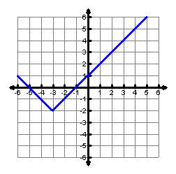
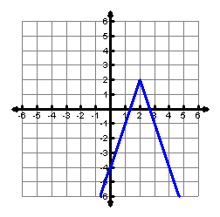
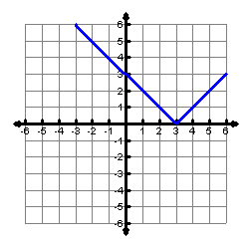
10. 11. 12.

Equation:________________

For what value of x is f(x) = -2?

______________________

Equation:________________

For what value of x is f(x) = 4?

______________________

Equation:________________

For what value of x is f(x) = 3?

______________________

