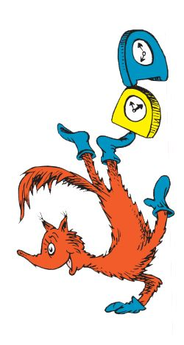
Dr. Seuss Week 2020
March 2nd-6th

Monday, March 2nd- Cat in the Hat/Bartholomew and the Oobleck Day
Wear a red and white striped, a Cat in the Hat shirt, or a red uniform shirt with uniform bottoms and a crazy hat. We will celebrate with birthday cupcakes (courtesy of Brookshire Brothers) for Dr. Seuss’s birthday.

Tuesday, March 3rd- Fox in Socks Day
Celebrate by wearing your uniform with crazy socks.

Wednesday, March 4th- Wacky Wednesday/Put Me in the Zoo Day
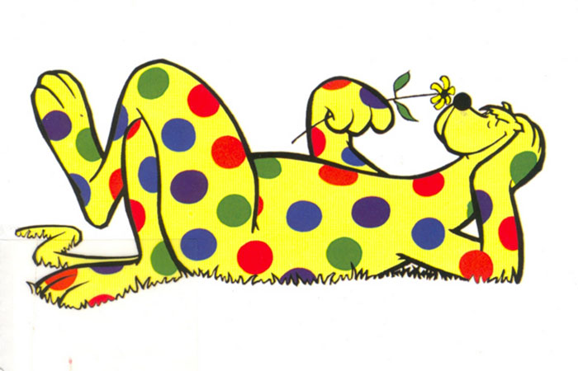
Celebrate by wearing your free dress backwards, inside/out, or wear something with polka dots.

Thursday, March 5th - Yertle the Turtle Day
Celebrate by wearing a blue shirt with your uniform bottoms and watching your teachers race to stack paper bowl turtles at lunch.

Friday, March 6th- The Lorax
Celebrate by wearing a yellow or orange shirt with blue jean bottoms.
Everyone will receive a silly mustache donated by PTK.

